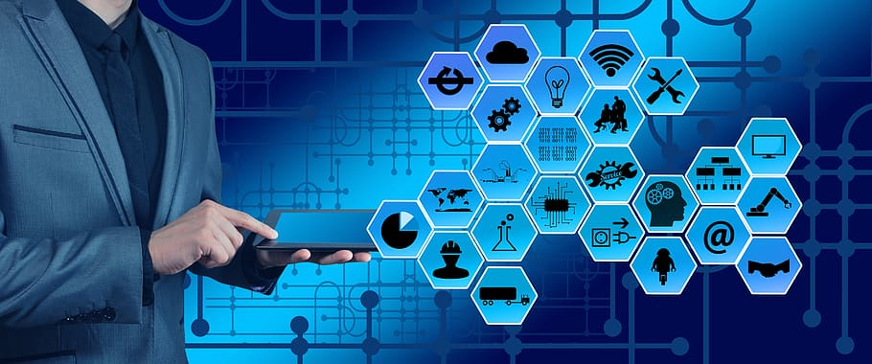
Information Technology (IT)
Introduction Information Technology (IT) refers to the use of computers, networks, storage, and other physical and virtual devices to store, retrieve, transmit, and manipulate data. IT plays a crucial role in various industries, enhancing efficiency, communication, and automation.

Key Components of IT
1. Hardware
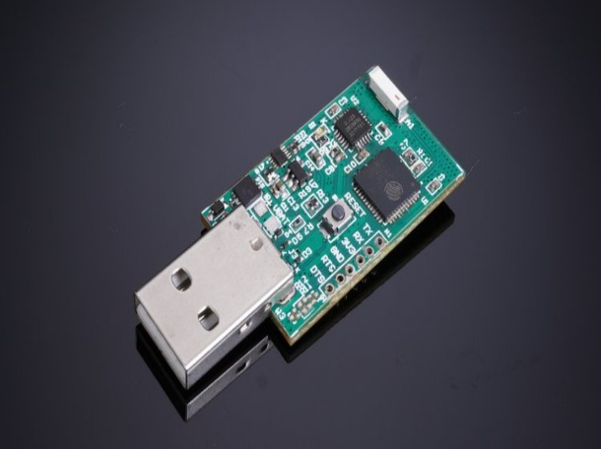
Hardware refers to the physical components of a computer or IT system. Examples include:
- Computers & Laptops – Used for data processing and software execution.
- Servers – Powerful machines that store and manage networked applications.
- Networking Devices – Such as routers, switches, and modems that enable internet connectivity.
- Storage Devices – Hard drives (HDDs), solid-state drives (SSDs), and cloud storage solutions for saving digital data.
2. Software
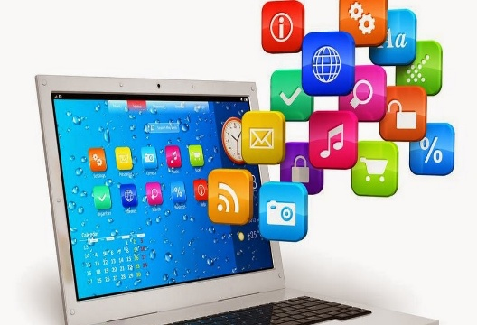
Software is the collection of programs and operating systems that allow computers and IT systems to function. Examples include:
- Operating Systems (OS) – Windows, macOS, Linux, and mobile OS (Android, iOS).
- Application Software – Microsoft Office, Google Chrome, Adobe Photoshop, etc.
- System Software – Manages hardware and provides a platform for other software (e.g., BIOS, drivers).

3. Networks
Networks enable devices to communicate and share data. They are categorized into:
- Local Area Network (LAN) – Connects devices within a limited area, such as an office or home.
- Wide Area Network (WAN) – Covers larger geographical areas (e.g., the internet).
- Wireless Networks (Wi-Fi, Bluetooth) – Enable communication without physical cables.
4. Databases
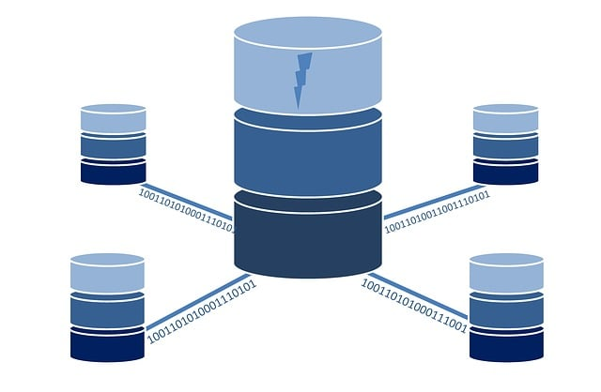
A database is an organized collection of data that allows efficient retrieval, updating, and management. Types of databases include:
- Relational Databases – MySQL, PostgreSQL (use structured tables and SQL for data management).
- NoSQL Databases – MongoDB, Firebase (handle large-scale, unstructured data).
- Cloud Databases – Hosted on cloud services like AWS, Google Cloud, or Microsoft Azure.

IT Infrastructure
IT infrastructure is the backbone of any organization’s technology environment. It includes the hardware, software, networks, and services needed to support the flow, processing, and storage of data. Here are the key elements of IT infrastructure:

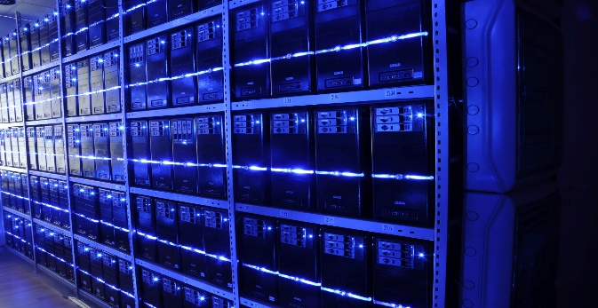
1.Data Centers
Data centers are facilities that house computer systems and associated components, such as servers, storage systems, and networking equipment. They are designed to ensure the reliability, security, and efficiency of IT operations.
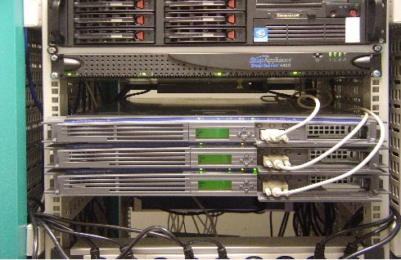
2.Servers
Servers are powerful computers that provide services to other devices on a network. They can be used for hosting websites, storing data, running applications, and more. Servers are essential for centralized computing.
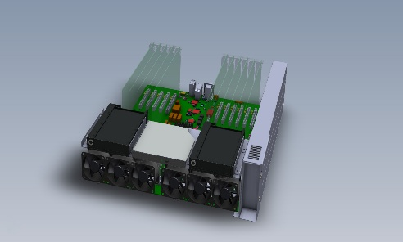
3.Storage Systems
Storage systems are used to store and manage data. This includes hard drives, solid-state drives (SSDs), and cloud storage solutions. Effective storage management ensures that data is accessible, secure, and backed up.
4.Networking Equipment
Networking equipment, such as routers, switches, and firewalls, enables communication between devices. It ensures that data can be transmitted quickly and securely across networks.

